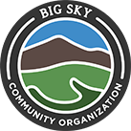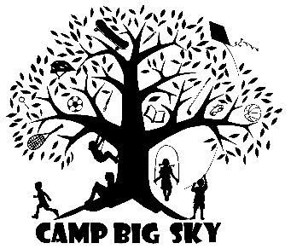
BSCO Camp Staff Job Description
About Big Sky Community Organization. The Big Sky Community Organization engages and leads people to recreational and enrichment opportunities through thoughtful development of partnerships, programs, and places. We envision a connected community. Managing 19 miles of public trail networks, 91 acres of public parks, and over 15 different community based programs we are committed to creating places for our community to experience, engage and connect.
About Camp Big Sky. Camp Big Sky is our popular youth day program. Our main focus at Camp Big Sky is to play outside, try new things and socially connect with other youth. We go on hikes, experiment with science, read books, play games/sports, and make crafts (just to name a few). Every week the campers receive professional instruction from golf and swimming pros. We also partner with the Historic Crail Ranch to explore the rich history of Montana. We provide a variety of programming to keep kids engaged. This is truly a community collaboration that provides the best summer that Big Sky has to offer its youth.
Position Overview and Essential Functions. The Camp Staff is a seasonal summer position under direct supervision of the Camp Big Sky Manager. Camp Staff will be an integral part to the daily operation of Camp all summer long. Camp Staff will manage groups of children and communicate with the Camp Manager throughout the day. This position will lead group activities and is responsible for the safety and function of all campers and staff under their supervision. In addition to the daily group management, this position will contribute to the activity planning.
Specific Duties.
Youth Supervisor (95%)
- Be attentive to and respond to camper, parent, staff, and guest needs.
- Help prepare, clean, and maintain a friendly, inviting space at the yurt daily.
- Lead and participate in group activities in a safe, fun, and educational manner.
- Assist guest instructors during their specific activities (eg. golf, swimming, archery, art).
- Assist other Camp Staff as needed.
- Communicate with the Camp Manager and all staff throughout the day.
- Maintain an exciting, inspiring energy to share with the campers.
- Be able to manage camper behavior in a way that aligns with Camp values.
- Apply situational-awareness to make on-the-go decisions with safety as the top-priority and respond to any First Aid needs.
- Become a part of our Camp community, developing relationships with campers, parents, staff, and guests.
Program Development (5%)
- Contribute ideas to Camp activity planning and program development.
- Lead programs as needed.
Qualifications.
- At least 21 years of age.
- Able to pass a background check.
- At least four years of experience working with children.
- Excellent leadership and interpersonal skills to manage groups of children.
- Knowledge of and willingness to participate in camp games, activities, crafts, and sports.
- Ability to confidently manage camper behavior.
- Receive and utilize First Aid and CPR training.
- Ability to spend all day outside in community parks and wilderness environments.
- Be a competent team member of Camp staff.
Preferred Skills and Background.
- Prior experience working at a camp.
- Professional certification to instruct or at least 4 years’ experience in one of our sport activities.
- First Aid, CPR, WFR, or WEMT certification.
- Lifeguard certification.
Compensation.
Camp Staff will be paid hourly at the rate of $14-$17/hr DOE and certifications. Part time Camp Staff will work 20 - 24 hours per week and Full Time Camp staff will work 32-40 hours per week. Required availability is weekdays M-F from June 10th-Aug 23th.
To Apply.
E-mail or mail cover letter and resume to Leisha Folley, Operations Manager leisha@bscomt.org or BSCO PO Box 161404 Big Sky, MT 59716. The deadline for applications is April 1, 2019 or until filled.

